**Design & Technology**

**Influence of Aesthetics**

**Multiple Choice**

**Materials required for questions**

* Pencil
* Rubber
* Calculator

**Instructions**

* Use black ink or ball-point pen
* Try answer all questions
* Use the space provided to answer questions
* Calculators can be used if necessary
* For the multiple choice questions, circle your answer

**Advice**

* Marks for each question are in brackets
* Read each question fully
* Try to answer every question
* Don’t spend too much time on one question

**Good luck!**

**Q1.** Which word is used to describe designing products well, so they are easy to use?

**A** Aesthetics

**B** Function

**C** Usability

**Q2.** Which of these is not influence aesthetic?

**A** Texture

**B** Convenience

**C** Colour

**Q3.** Why should a designer be mindful of the colours selected for a product?

**A** Some colour choices may have cultural

barrier

**B** Some colour choices may make the

product less flexible

**C** Some colour choices may stop the

product from working correctly

**Q4.** What does aesthetics mean?

**A** User-centred design

**B** Measurements of the human body

**C** The way a product looks and feels

**Q5.** What does the colour blue universally represent?

**A** Cold

**B** Warmth

**C** Nature

**Q6.** Aesthetics relates to a product’s?

**A** Looks

**B** Cost

**C** carbon footprint

**Q7.** Explain why surface finishes are applied to material and fabrics for aesthetic reasons

Give examples in your answer **(3 marks)**

**Q8.** Designers must prioritise form or function when designing products. Discuss how the designer of the PS5 controller has balanced form and function in the design **(6 marks)**

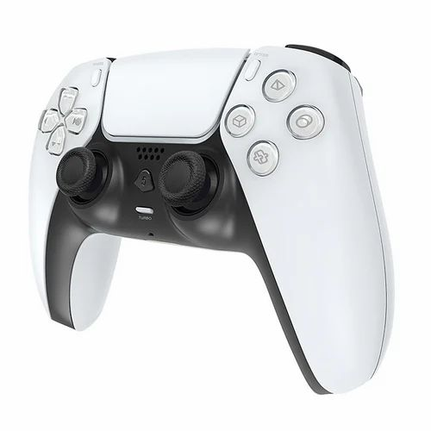

**Q9.** William Morris believed that form should follow function. Explain **two** ways in which the chair shown below shows this philosophy **(4 marks)**

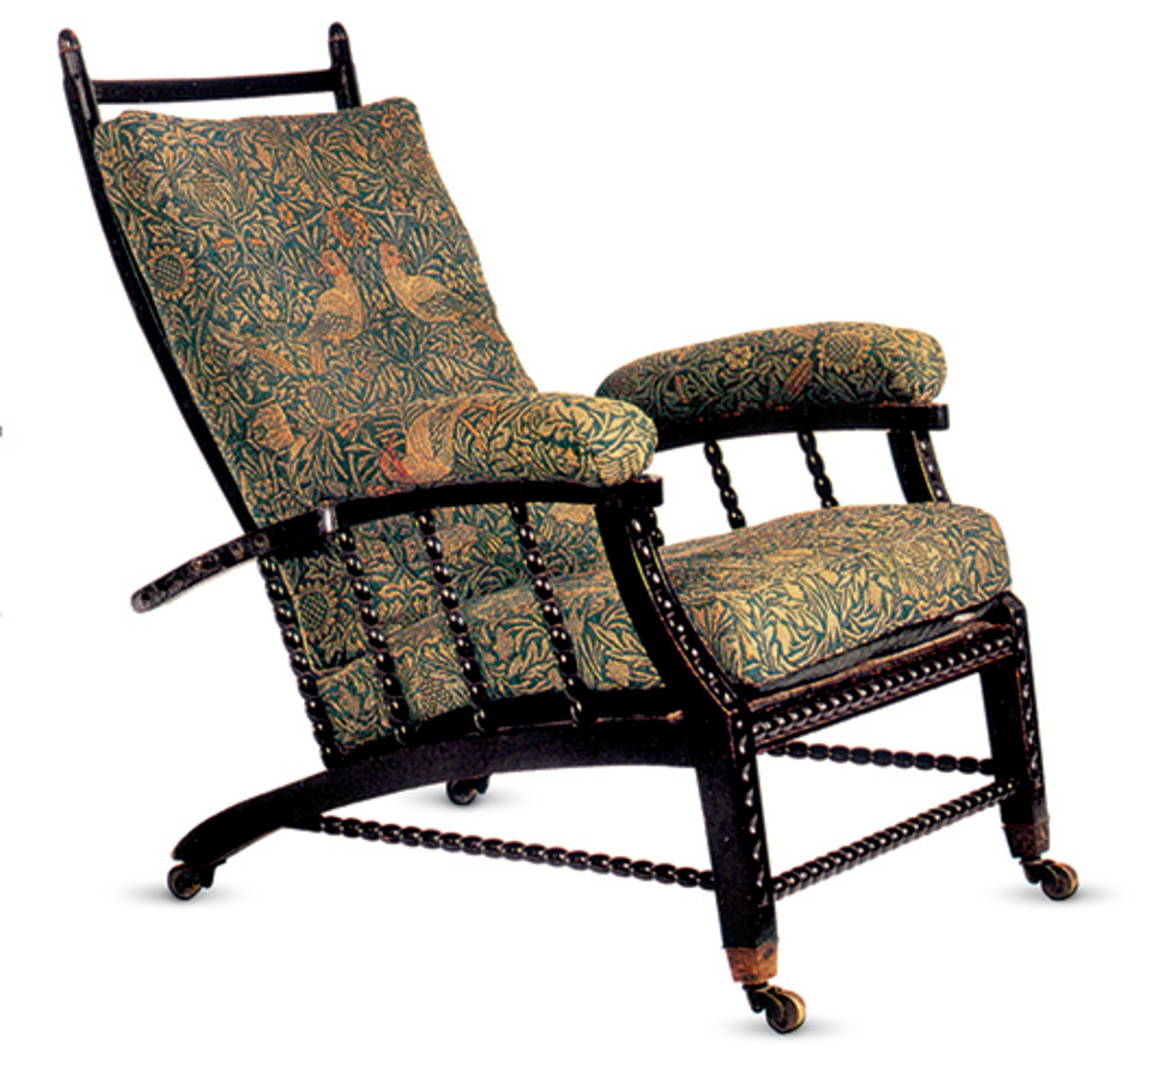

**Answers**

**Q1. C  
Q2. B  
Q3. A  
Q4. C  
Q5. A  
Q6. A**

**Q6. A**

**Q6. C**

**Q7.**

Any named aesthetic reason:

* Change the colour of a product
* Improving appearance/make the product look more attractive
* Change the look and feel of a product
* Aesthetic finish examples:
* Painting cars different colours to suit different customer tastes
* Embossing in card to create a decorative 3D effect
* Self-finished surface, eg the injection moulding process can ‘build in’ a textured surface in contrast to a smooth surface
* Add to decoration and quality of finish, eg enamelling jewellery
* Wood stains to enhance the colour of timber
* Anodising to produce brightly coloured aluminium products, eg bike wheels, Maglites
* Stonewashing jeans (distressing) gives a soft peach skin effect
* Heat setting thermoplastic fibres to give crushed effect, creases and pleating

**Q8.**

Candidates might refer to the following in their responses:

* Form follows function
* Function follows form
* Shape/form
* Key functions
* Ergonomics and anthropometrics
* Demographics of the user group
* Proximity of key controls to fingers and thumbs
* Range of hand movement
* Shape of handles
* Comfort in use
* Ease of use
* Aesthetics

**Q9.**

* Comfortable / comfort is key (1) cushioned / fabric covered seating surfaces / arm rests (1)
* Ergonomically shaped / supports user in a relaxed posture (1) reclined angle of seat and back / shaped uprights follow contours of a person’s back / high back gives full support to back and neck / avoids back pain / strain (1)
* Anthropometrically designed / considers human dimensions (1) suitable height seat / back (1)
* Easy to move about (1) casters added to feet (1)
* Stability / will not tip easily (1) as the base of the chair is relatively large / long back legs (1)
* Sturdy, robust, chunky structure (1) as braces interlink all components / that will withstand long term use / users sitting down heavily (1)
* Little artificial decoration added / every part has a function (1) resulting in simple / humble styling.